Write the prolog program to implement family tree.

**AIM**

To write a Prolog program to represent a family tree and find relationships like father, mother, and siblings.

**ALGORITHM**

1. Start the program.
2. Define parent facts to store parent–child relationships.
3. Define male and female facts for gender information.
4. Write rules:
   * father(F, C) if F is male and parent of C.
   * mother(M, C) if M is female and parent of C.
   * sibling(X, Y) if X and Y share a parent and are not the same person.
5. Load the program into Prolog.
6. Query the program to find family relationships.
7. Stop.

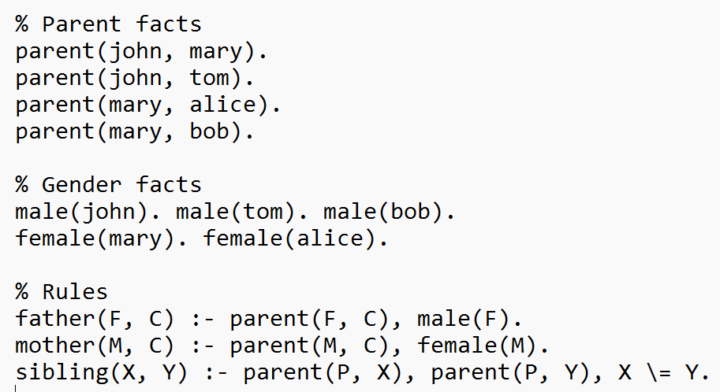

**OUTPUT:**

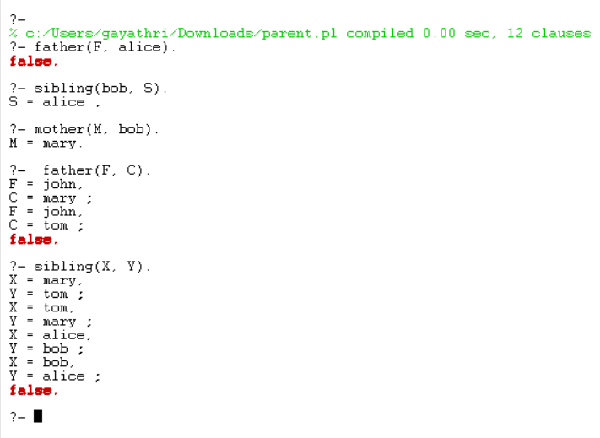

**RESULT**

The program successfully represents a family tree and retrieves information about fathers, mothers, and siblings from the database.